9*

CHAPS MOUNTAIN TRAIL

TRI-STATE REGION

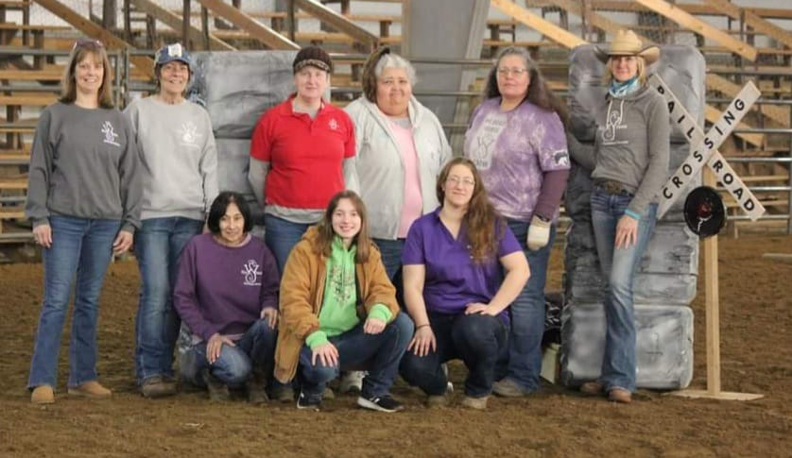
WS ROAD COURSE SERIES team

LAURA WIENCEK AMY DIVERS KRISTAANA WASKOWIAK
NICOLE WOOD JAMIE BARTO
ELLEN COOK AMANDA LYNN
JUDY HEINZ LINDA GOLDING

CHAPS (COMPETITIVE HORSES AND PARTNERSHIPS RULES AND DIVISIONS)
1. Open to any discipline and breed of EQUINE.
2. All riders must sign a release form. Riders 18 years or age and under must
have parent/guardian signature on release form. Competitors and
parents/legal guardians of youth assume all responsibility when on the
grounds and participating in the event.
3. Riders must pay a non-refundable entry fee.
4. Equines must be serviceably sound and in good condition as determined by
the judge.
5. It is expected that each horse shall be treated humanely with kindness and
respect always.
6. The judge always has the option of disqualifying an exhibitor for safety
reasons, disrespect, or misconduct.
7. No whining, moaning, or complaining. The object is to have fun and to
better our horsemanship. Suggestions are welcome.
8. No horses on the course before their turn unless directed. (No practicing obstacles on competition day.)
9. If you happen to fall off your horse and you can regain control without
assistance and remount you may do so. However, you will receive 0 for horsemanship and a deduction for that obstacle for the obstacles challenge. Judged trail ride Disqualification arises if horse comes back without rider.
10.The judge will ask contestant to move on to next obstacle
upon the third refusal or after 30 seconds of not completing an obstacle.
The rider MUST move to the next obstacle. Riders who do not move on will
be disqualified!
11.Failure to attempt an obstacle results in a -10 for that obstacle.
12.It is permissible to change rein hand or ride two handed to work with an obstacle if riding one handed.
13.Judge/Ride Host has the right to add additional rules if necessary. Rule
additions will be posted at registration table. Judge/Ride Host has final word.

TACK & ATTIRE
• Boots with a heel are mandatory.
• Show clothing not required.
• Clothing should be nice, neat, and appropriate for the weather. No tube tops or spaghetti straps.
Numbers: The number, if issued, will be displayed in a visible manner.
Tack: must be safe, humane and in good working condition. Equipment must
work through entire course.
Snaffle Bits and Bosals: Any horse may be shown 2 handed using a snaffle or
bosal. Horses that are shown in bit with a shank should be ridden one handed. Use of two-hands on reins when using a shank bit are penalized in your horsemanship score.
Bits should be appropriate for discipline, fitted correctly and not cause your mount undue discomfort.
Bitless bridles, rope halters permitted provided contestant can maintain control of their mount.
NO: Tie-downs, draw reins, martingales, or wire chinstraps.
Exhibitor Order will be determined by show management by drawing and
posted. Accommodations are made for exhibitors with multiple horses.

COURSE WALK THROUGH/RIDERS MEETING
A course walk-through and/or riders meeting for competitors will be at least 30 minutes before competition begins for first group of classes. Remaining classes will have a walk-through before their classes. A course map and patterns will be posted before the walk-through and on our event pages. It is the competitor’s responsibility to fully understand the course and rules currently. Obstacles must be completed in the designated order.
In Novice level 1 and youth level 1 it is acceptable for a reader to remind rider of the obstacle order. 1 point will be deducted on your horsemanship score. Riders with disabilities will not be penalized.

SAFETY
Obstacles are designed with safety in mind. However, if judge or ride host feels an obstacle is beyond the abilities of you and/or your horse you will be asked to skip that obstacle. The judge or ride host may deem an obstacle unsafe due to weather, etc. and has the right to make changes accordingly.

JUDGING
Each contestant will perform the required trail pattern individually. The best trail
horse will be willfully guided with no apparent resistance. Any movement made
by the horse on its own or deviation from the pattern must be considered a lack
of control. Credit will be given for horsemanship, smoothness, calmness, finesse,
forward motion, control, attitude, quickness, and authority in performing the
various obstacles while using controlled speed. This event is intended to display
the versatile working ability of a solid trail horse.
A good horseman will never endanger themselves or their horse. A good working
relationship between horse and rider should be rewarded. Riders will abide by
the ruling of the judge.
All judges’ decisions are final.
The judge should walk course and make any adjustments necessary for safety.

SCORING
Each obstacle will be worth 10 points.
Obstacles not attempted or forgotten will receive a -10.
2 | 6 | 2
-10 – Not Attempted or forgotten.
-9 (-1, -6, -2) – Attempted, 3 refusals
-8 (-6, -2) Two feet or obstacle entrance executed but body and exit not completed.
-5 – Attempted but not completed.
-5 Off Course.
-5 Excessive whipping/Spurring
-3 Disobedience
-2 Horse Distracted.
-2 Rearing.
-2 Falls off obstacle.
-2 Drops obstacle/Lets go of Gate.
-2 Doesn’t exit at Exit
-1 Point per Tic up to ( -2 -6 -2 )
-1 Rushing
-1 Hopping In/Out
-1 Break of Gait/Wrong lead/ Wrong Gait.
-1 Knock/Roll
-1 One foot out of obstacle.
-1 Consistent Tight Rein.
-1 Steps away from ground tie.
-1 Hesitation
0 Horsemanship score for an unintentional dismount.
1- Slightly off center.
1 – Not a full horse length.

HORSEMANSHIP
5 – RIDER QUIET, CONFIDENT, TACK WELL FITTED AND CLEAN. HORSE QUIET AND CONFIDENT, HUNTING OBSTACLE, LEVEL
4- 2 HANDS RIDING IN SHANK BIT
4- DIRTY TACK
4 - POOR TURNOUT
3- HEAD TO LOW OR OVER FLEXED
2 – EQUIPMENT FAILURE OR UNSAFE
2- ILL FITTING TACK
1 – EXCESSIVE USE OF HANDS TO INSTILL FEAR OR PRAISE
1 – JERK ON BIT
1 – EXCESSIVE SPURRING

BONUS POINTS AWARDED
Obstacle completed willingly with finesse
Obstacle completed willingly w/ a higher degree of difficulty
Obstacle completed willingly w/ a higher degree of difficulty and extreme
finesse

ENTRY DISQUALIFIED

INAPPROPRIATE TO JUDGE OR RIDE HOST
IMPROPER LANGUAGE TO JUDGE
HORSE OR RIDER FALLS – UNABLE TO FINISH
ABUSE/AGGRESSIVE SCHOOLING

Each event will give awards to Sixth Place.
FOR TRISTATE REGION ONLY:
Cumulative points will go to Sixth Place. (Example – First Place – 6 points,
Second Place - 5 points and so on to Sixth Place.)
Points will accumulate through the season.
Riders must attend at least 2 Road Coarse events to qualify for yearend awards for the Road Coarse Series.
Riders must attend at least 4 events at Win-Seek to qualify for awards for the Home Course Series.
Riders must attend at least 4 of the scheduled challenges at our home course and at least two road course challenges to qualify for Year End Awards for the combined series.
CHAPS DIVISIONS
YOUTH –
Open to riders under 18 years old as of January 1. All youth must wear helmets.
NOVICE –
For beginner horses or riders, who have never competed in CHAPS or competitive trail events prior to this year. Walk/Trot. A horse or rider qualifies for this division for two years only.
The Novice Division is designed for base level riders who have developed only the
basic riding skills, backing and side passing, etc. and have had little or no experience competing in other equestrian events. The Novice Division is considered an entry level division that will allow the rider to develop confidence skills needed in the next level. The purpose of the Novice Division is to level a division that is fair to all base level riders.

ADULT–
Open to all riders 18 and over. Walk/Trot/Lope. Adult rider has increased horsemanship skills such as increased speed and confidence in their basic skills
and are prepared for the challenges of this higher level. A rider in this division has
had some competition experience in equestrian sports and/or obstacle trail
events.
Novice may enter Adult Level 1 and 2.

NOVICE – Has never won a Division buckle at an event or other obstacle/trail ride. Does not give lessons in other disciplines or train.

OPEN/MASTERS --
Open to all horses and riders except Novice. Walk/Trot/Lope.

DIVISION RULES –
◼ Cross entering is permitted. Novice cannot ride Open/Master or ride Adult Level 3. For example – Youth rider can potentially ride in Youth and Open but entry fees will be collected for each division.
If Rider chooses to ride multiple horses at ONE event, each additional horse will be deemed a NEW entry. Entry Fees will be collected for all horse/rider combo at each event. Please make office aware horses need to be separated in the division to allow rider time to switch.
◼ Judge will choose tie breaker.
◼ In the event of a tie score in any division for END OF YEAR AWARDS, the tie
breaker will be 1) rider with highest number of events attended. 2) rider
with the most first placings in division.

